 Version: 1.0.0 October 2017

2.4GHz Band Wireless Product Antenna Design Guide

© 2017 Anyka (Guangzhou) Microelectronics Co. Ltd. All rights reserved.
Statement
The copyright of this manual belongs to Ankai (Guangzhou) Microelectronics Technology Co., Ltd. and is protected by relevant laws and regulations. No one may copy or disseminate the contents of this manual without the prior written permission of Ankai (Guangzhou) Microelectronics Technology Co., Ltd.
The intellectual property rights involved in this manual belong to Ankai (Guangzhou) Microelectronics Technology Co., Ltd. (or authorized by its partners for use), and no one may infringe upon them.
This manual does not guarantee the following matters, including but not limited to: merchantability, suitability for a particular purpose; implementation of such use will not infringe the intellectual property rights of a third party.
Ankai (Guangzhou) Microelectronics Technology Co., Ltd. is not responsible for any damages caused by the use of this manual or the execution of the contents of this manual.
This manual is provided for reference in its current state. If the accompanying products or the contents of this manual are changed, no further notice will be given.

Contact
Ankai (Guangzhou) Microelectronics Technology Co., Ltd.
Address: 3rd Floor, C1 Zone, Innovation Building, No. 182, Science Avenue, Guangzhou Science City
Tel: (86)-20-3221 9000
Fax: (86)-20-3221 9258
Postal Code: 510663

Sales Hotline:
(86)-20-3221 9499
Email:

sales@anyka.com

Home:
http: //www. anyka.com

Version Change Description
The following table briefly describes the version changes of this document. Version changes are limited to changes in technical content and do not include changes in layout, format, syntax, etc.

Version | Description | Completion Date
V1.0.0 | Official Release | October 2017

Table of contents
1 Document Introduction 3
2 Basic principles of antenna design and use 3
2.1 Antenna Requirements 3
2.2 Antenna Selection Examples 4
2.3 Antenna feed line 5
2.3.1 PCB routing and corresponding instructions 5
2.3.2 Precautions for routing coaxial cable feeder lines 7
2.4 Antenna installation layout 8

Document Introduction
In order to ensure a good communication effect in the 2.4GHz frequency band, in addition to impedance matching on the PCB and impedance control of the traces, the design and selection of the antenna must also be considered. This article mainly introduces some basic principles of antenna design and use to help customers design antennas more reasonably.

Basic principles of antenna design and use

Antenna Requirements
Frequency Range | Bandwidth | Impedance | Gain | Efficiency | VSWR | Polarization
2360 ~ 2520MHz | > 150MHz | 50Ω | > 1dBi | > 50% | < 2.0 | Linear

Parameter Description：
- Working frequency band: refers to the range between the lowest working frequency and the highest working frequency of the antenna；
- Bandwidth: usually refers to the frequency bandwidth within the range of 3dB decrease in antenna gain；
- Impedance: The characteristic impedance presented to the signal, not the DC internal resistance；
- Gain: The ratio of the radiation capacity in the maximum radiation direction to the ideal omnidirectional point radiator；
- Efficiency: Antenna efficiency refers to the ratio of the power radiated by the antenna (i.e. the power of the electromagnetic wave part that is effectively converted) to the active power input to the antenna.；
- Standing wave ratio: Since the input impedance of the antenna and the characteristic impedance of the feeder cannot be completely consistent, some signal reflection will occur. The reflected wave and the incident wave are superimposed on the feeder to form a standing wave. The ratio of the adjacent maximum and minimum voltages is the voltage standing wave ratio (VSWR).；
- Polarization: The orientation of the electric field vector of an antenna in the direction of maximum radiation (or reception).

In addition, pay attention to the radiation pattern of the antenna to avoid communication blind spots for the product when the antenna is installed, as shown in Figure 2-1.
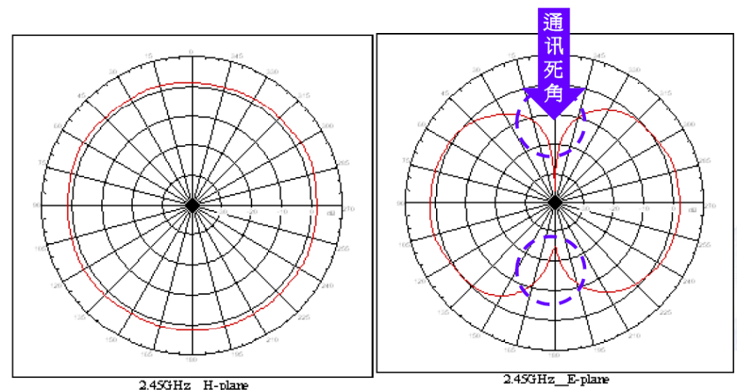
Figure 2-1 Schematic diagram of communication blind spots

Antenna Selection Examples
1. Figure 2-2 is a specification description of a ceramic antenna. From the specifications, we can see that the bandwidth of the antenna is too narrow and the gain is too small, so it is not recommended for use.
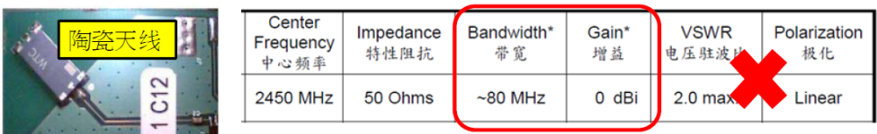
Figure 2-2 Specifications of a ceramic antenna

2. Use a metal antenna or PCB antenna with good bandwidth and efficiency. The antenna bandwidth is recommended to be greater than 150MHz to cover and exceed the operating frequency band of BT/WLAN, as shown in Figure 2-3.
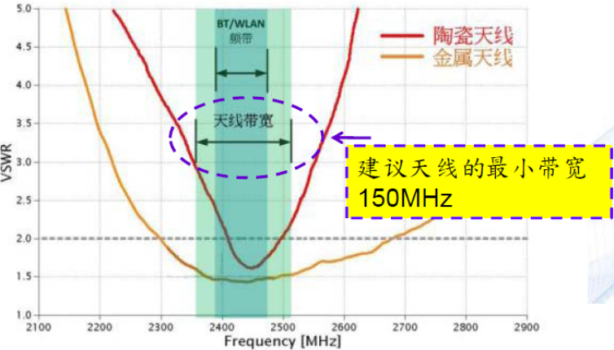
Figure 2-3 Antenna bandwidth selection

Antenna feed line
The feed lines of 2.4GHz antennas are typically divided into two types: PCB traces and coaxial cables.

PCB routing and corresponding instructions
The width of the feeder line on the PCB must take into account the impedance characteristics of the line segment, and its impedance value must be designed to be around 50Ω. There must be a complete PCB ground plane under the line as a reference plane. Figure 2-4 is the calculation result of the line width on the FR4 printed circuit board.
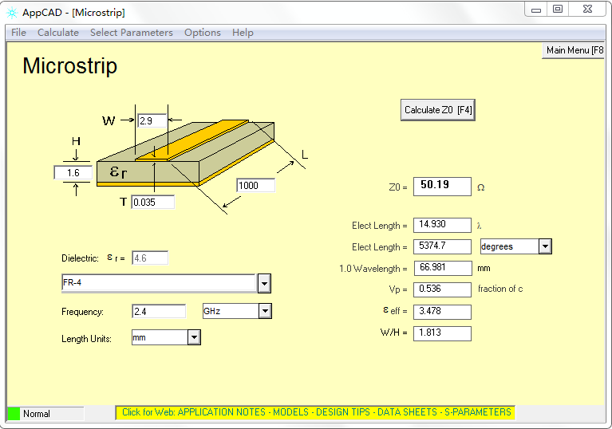
Figure 2-4 FR4 printed circuit board trace width calculation results

Explanation：
1. The longer the feeder line is, the greater the energy loss is, so the shorter the line is, the better.
2. The feeder routing cannot have bifurcations, which will cause impedance discontinuity and signal reflection.
3. When the feeder line needs to turn, it cannot be routed in a corner. Instead, it must be bent in an arc, as shown in Figure 2-5.
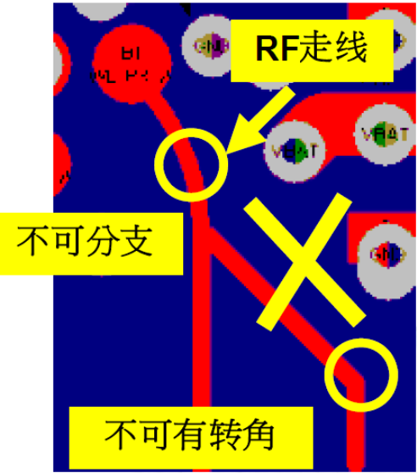
Figure 2-5 Feeder routing bends

4. The position of the impedance matching network components needs to be reserved between the feeder and the antenna to correct the impedance characteristic deviation caused by the feeder in actual situations. The matching components should be arranged as close as possible to the RF port at the circuit end, as shown by components such as C5, C7, C9, and C37 in Figure 2-6.
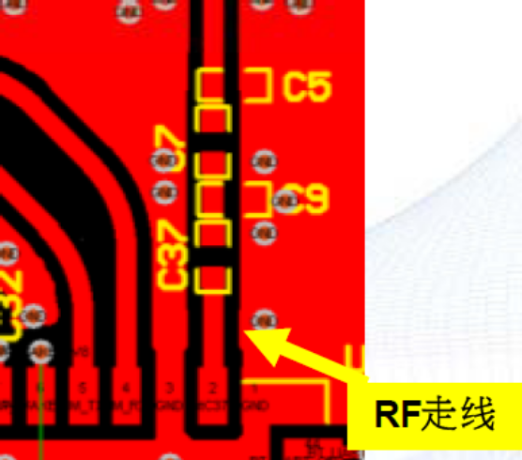
Figure 2-6 Component layout

Precautions for routing coaxial cable feeder lines
When connecting the coaxial cable feeder to the PCBA, try to use an RF connector. If you do not use a connector, do not strip too much shielding when stripping the coaxial cable, otherwise the 50Ω impedance of the cable will be discontinuous, causing signal reflection. Figure 2-7 shows the correct and incorrect stripping methods.
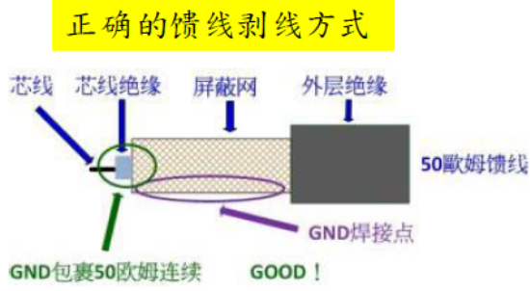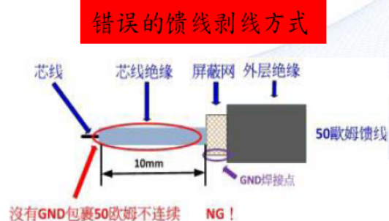
Figure 2-7 Correct and incorrect feeder cable stripping methods

Antenna installation layout
It is recommended that metal objects around the antenna body be at least 10 mm away from the antenna, and avoid using metal casings in the radiation direction of the antenna.

